**Mini Project Report**

**ON**

**“VIRTUAL TRAIL ROOMS”**

Submitted in partial fulfilment of the requirements of the requirements for the degree of Bachelor of Engineering in

“Information Technology Semester-VI”

By

|  |  |  |
| --- | --- | --- |
| .No | Name | ID No. |
| 1 | Rutuja Sirsikar | VU4F1920009 |
| 2 | Digvijay Phutane | VU4F1920013 |
| 3 | Ritesh Jaiswal | VU4F1920014 |
| 4 | Sheetal Munde | VU4F1920016 |



Under the Guide of:- **Prof. Vedika Avhad**



**Department of Information Technology**

**Vasantdada Patil Pratishthan's College of Engineering & Visual Arts**

**UNIVERSITY OF MUMBAI**

# (AY 2021-22)

**CERTIFICATE**

This is to certify that the project entitled **“Virtual Trial Rooms” is a bonafide**

**work** of “Rutuja Sirsikar (vu4f1920009), Digvijay Phutane (vu4f1920013), Ritesh

Jaiswal (vu4f1920014), Sheetal Munde (vu4f1920016)” submitted to the University of

Mumbai in partial fulfilment of the requirement for the award of the degree of

**“Bachelor of Engineering” in “Information Technology - Semester - VI”**

Prof. Vedika Avhad

Guide

DR RAHUL KHOKALE DR ALAM SHAIKH

Head of Department Principal & Campus Director

**Project Report Approval for T.E.**

This project report entitled (“Virtual Trial Rooms”) by (Rutuja Sirsikar, Digvijay Phutane, Ritesh Jaiswal, Sheetal Munde) is approved for the degree of **“Bachelor of Engineering”** in **“Information Technology”**.

Examiners

1.

2.

Date:

Place: Mumbai – 22

Submitted by:

|  |  |  |
| --- | --- | --- |
| Sr No. | Name | ID No. |
| 1 | Rutuja Sirsikar | VU4F1920009 |
| 2 | Digvijay Phutane | VU4F1920013 |
| 3 | Ritesh Jaiswal | VU4F1920014 |
| 4 | Sheetal Munde | VU4F1920016 |

## **ABSTRACT**

People usually avoid buying wearables like clothes, ornament, etc. online mainly because it's hard to judge whether it will look good on them or not. To solve this problem, we decided to build an Online Trial Room Application. Our research is based on creating an application which takes a video of the user using the device camera and then divides the video into individual frames from which it extracts the user's body. Finally using functions to extract information on the placement of joints in the body and to transform, rotate, and scale the wearable image onto the user in real-time. In the literature review, we go through various ways to achieve our goal with their advantages and disadvantages. The project is implemented in Flask Web application with OpenCV a Python Module. The application works on devices with an inbuilt or attached camera, internet, and web browser.

### ACKNOWLEDGEMENT

We feel great pleasure in submitting this project paper on Virtual Trail Rooms. We wish to express a true sense of gratitude towards our project guide, Prof. Vedika Avhad who at every stage in the study of this project, contributed her valuable guidance and helped to solve each and every problem. Our great obligation would remain due towards Dr. Alam N. Shaikh ( Principal ) who was a constant inspiration during our project. He provided us with an opportunity to undertake the project at Vasantdada Patil Pratishthan's College of Engineering and visual arts, Mumbai. I feel highly indebted to them who provided us with all our project requirements, and did much beyond our expectations to bring out the best in us. I sincerely thank our respected Head of Department Dr. Rahul Khokale, he proved to be a constant motivation for the knowledge acquisition and moral support during our course curriculum.**.**

**CONTENTS**

1. **INTRODUCTION**
   1. INTRDUCTION DESCRIPTION
   2. ORGANIZTION OF REPORT
2. **LITERATURE REVIEW**
   1. SURVEY EXISTING SYSTEM
   2. LIMITATION EXISITING SYSTEM AND RESEARCH GAP
   3. PROBLEM STATEMENT AND OBJECTIVE
   4. SCOPE
3. **PROPOSED SYSTEM**
   1. ALGORITHM
   2. DETAILS OF HARDWARE AND SOFTWARE
      1. SYSTEM ARCHITECTURE
   3. DESIGN DETAILS
      1. SYSTEM ARCHITECTURE
   4. METHDOLOGY/PROCEDURES
4. **RESULT AND DISCUSSIONS**
   1. RESULTS, DISCUSSION- COMPARATIVE STUDY/ ANALYSIS
5. **CONCLUSION FUTURE WORK**
6. **REFERNCES**

**INTRODUCTION**

* 1. INTRDUCTION DESCRIPTION

With the advanced technology growth, online shopping as known as e-shopping has grown exponentially throughout the world nowadays. Advances in e-shopping has driven a shopping revolution where customers are able to purchase items anywhere and anytime. Despite the benefits of e-shopping, the main drawback is the difficulty for online shoppers to try items on especially for clothing. Hence, a virtual fitting room using AR is proposed to be developed as a mobile application to allow shoppers to visualize how clothing looks and fits on their bodies without wearing it actually. This is to improve shoppers’ shopping experience by giving them an ability to virtually try clothing on in order to check for size, fit or style. In this development, AR, human body detection and motion tracking are integrated to fit the model of garment to user’s body in real-time by tracking user’s body movements through the smartphone camera. The body skeleton-joint positions are recognized, detected and tracked using pose estimation model. In addition, the body and garment measurements are also analysed and interpreted to help in seamlessly fitting the virtual garments to the body.

In recent years, with the rapid development of the technology, virtual reality has gradually become the trend of the times. With the rapid development of technology, the virtual fitting room technology has come into being, which is applied in both physical and online stores. For the online part, compared with the traditional offline shopping method, online shopping is not bound by time and space. However, for the clothing retail industry, different brands have different materials and sizes, and it is difficult for users to have accurate assessment and control of clothing sizes. Users can simply scan their body contours and input relevant body data to browse and try on their favorite clothes online. Online virtual fitting rooms provide a platform for users to quickly try on clothes, allowing consumers to get the right size of products in a short period of time. For the instore part, Offline users are able to experience convenient and fast virtual changing technology in physical stores, saving dressing time and improving shopping efficiency. At the same time, stores are able to reduce the cost of fitting rooms and gain more display and shopping space.Virtual fitting technology can not only significantly improve the efficiency of consumer purchases and greatly reduce the return rate, but also help companies grasp more user data, analyze this data to accurately recommend products for users, design new products based on demand, and reorganize promotion and marketing models, thus enabling brands to increase profits[1]. The virtual fitting room has attracted worldwide attention as a highly promising and mature online virtual fitting technology

**LITERATURE REVIEW**

* 1. SURVEY EXISTING SYSTEM

Virtual Fitting Room by ZeekitZeekit, a fashion tech start-up has developed the first virtual fitting room application which offers an interactive and different shopping experience for every person. It allows online shoppers to see themselves in any piece of garment found on-line without having to physically try it on by using uses their real photo and body measurements. Using real-time image processing technology, Zeekit map a person’s image into thousands of segments by using its patented technology which involves rendering 3D maps over a 2D images. Besides, garment is also processed using the similar technology. Then, the processed person’s image and garment are re-mapped into final simulation based on the equivalent points of them. The final simulation shows a person dressed virtually, taking into account few factors such as body measurements, size, fit and the fabric of the garment in accurate way.

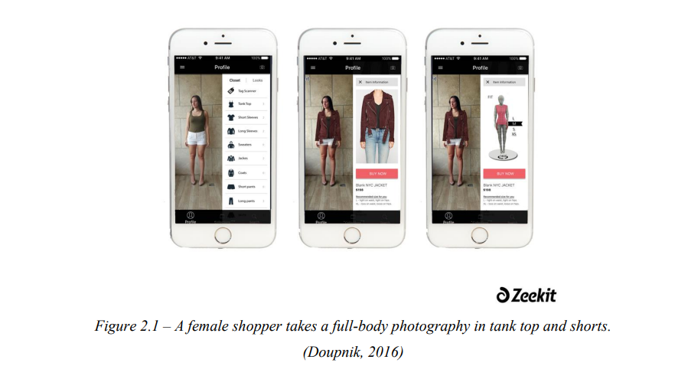

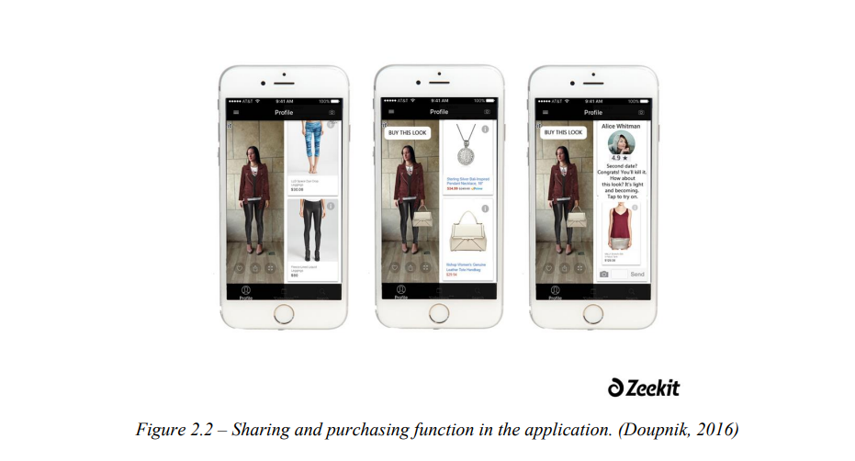

As shown in Figure 2.1 and Figure 2.2, shoppers need to first upload a full-body picture of themselves in a tank top and fitted shorts or a little dress in order to make sure that their body shape is apparent. In this way, the application is able to analyse their bodies and turn 2D pictures into 3D data to create a realistic image of how garment looks on their bodies. The application then estimates their body measurements such as waist, bust, hip which the shoppers can adjust freely. After that, the shoppers tap any product they see online, in print or in store to instantly view how it looks and fits on their actual body by using the uploaded image of themselves. Each garment they try on can be mixed and matched from different retailers in their virtual closet, shared with friends or purchased through a link in the application. In addition, retailers and brands can easily incorporate the Zeekit button into their online, mobile and physical stores to allow shoppers to virtually try on their entire catalogue of products. For instance, Zeekit cooperated with Rebecca Minkoff, a fashion company to new retail technology to the luxury market. Through this, Rebecca Minkoff’s consumers are able to instantly access the feel of its products with immediacy through Zeekit application in order to try on products and purchase them.

* 1. LIMITATION EXISITING SYSTEM AND RESEARCH GAP

Based on the existing systems reviewed, there are some strengths of the solutions used to solve the problem while there are also weaknesses and limitations of the solutions.First and foremost, Zeekit’s virtual fitting room is an application which allows users to instantly view how the selected garment looks and fits on their body in image. Based on the uploaded full-body picture of user, the application analyses user’s body measurements such as waist, bust, hips which user can adjust them freely to provide more accurate measurements. As the application also turns a 2D image into 3D data, it is able to adjust the virtual garment to fit to user’s bodies based on the body measurements. Furthermore, retailers and brands are allowed to incorporate the Zeekit button in their online, mobile and physical stores so that their shoppers could enjoy the try-on function. In addition, users are able to share with friends or purchase from different retailers through a special link in the application. On the other hand, the main weakness of the application is that the try-on function is in static mode. The final simulation of virtual garment and human body is in static image which could not be view in different angles. Users are unable to feel the realism as they only can view how the virtual garment looks on the front body. In this case, users might not be interested in the try-on function as it does not help users much in deciding whether to purchase it or not.

Virtual Reality implementation is no good if it does not feel reality though its only possible if the user can get the exact same feeling as they get when they wear a cloth like the feeling of wearing a cotton cloth is different from that of wearing woolen cloth. Though even though we can’t provide with that level of realism right now at least we can make user’s view more realistic as if they are trying the cloth in a mirror inside an actual Tryon room. Augmented Reality is direct and indirect view of realworld elements that are augmented on computer software. Augmented Reality considers real and virtual elements. It mainly adds the software information and refines the users view to the actual environment. In most augmented reality pleas, a user will see both synthetic and natural light. This is done by overlaying projected images that allow the images and interactive virtual objects to a layer on top of the user's view of the real environment. Augmented Reality devices are often self-contained, they are completely untethered and do not need a cable or desktop computer to function. OpenCV is an abbreviated form of Open Source Computer Vision Library which supports python, C++, java interfaces. It is basically designed to for achieving computational efficiency and also to give emphasis for real time applications. This package has an added advantage that is multi core processing when the code is written in C or C++. Using augmented reality technology reduces the time of the customers and also the chaos created while purchasing the wearable by virtually trying them online.

* 1. PROBLEM STATEMENT AND OBJECTIVE

With the advanced technology growth, online shopping as known as e-shopping has grown exponentially throughout the world nowadays. Advances in e-shopping has driven a shopping revolution where customers are able to purchase items anywhere and anytime. Despite the benefits of e-shopping, there are some disadvantages which deter customers from purchasing items online. The most common problem faced by online customers is unable to try things on especially for clothing. Most of the them wish to check whether the clothing fits in size as sometimes the purchased clothing does not match with the size description provided by the seller. Offering return polices or free shipping for returns is aim to compensate for inadequate fit and sizing content but it will bring much inconvenience to the seller. Furthermore, some of the customers may prefer to shop in-store in order to try clothes on so that they can know whether the clothing fits them or not. However, for popular clothing store, the fitting rooms are usually full and there are long queues at peak hours especially holidays. Customers may need to queue up for a long time just to try few clothes on, thus lead to customer dissatisfaction. In fact, customers will choose one or both of the clothing shopping styles which are online shopping and in-store shopping based on their specific demands. However, both of the ways are unable to achieve a goal which is allowing customers to check for size, fit or style of their favourite clothing without physically trying it on body. Therefore, an AR virtual fitting room is proposed in this project in order to help customers to accomplish their shopping goals.

The main objective of the proposed system is to enhance customer experience in clothing fitting by enabling customers to virtually try clothing on in order to check for size, fit or style. In this way, customers are able to shop and try their favourite clothing anywhere and anytime with smartphone. The main objective of the project is divided into subobjectives as shown as below.

To detect and extract human body skeleton-based joint positions using smartphone camera. The human body detection system is developed to detect the body parts included head, lower and upper body with minimum latency. The system should be able to inform the user about successful or unsuccessful human body detection by displaying the detected body skeleton-based joints or error message respectively.

1. In addition, the time needed for detection and extraction should be shorter as compared to physically changing clothes or else this application does not make any contribution to time advantages for users.
2. To calculate body measurements based on the extracted body skeleton joint positions. Body measurements are utilized to fit the virtual garments over human body in a more accurate way. The body measurements, including shoulder width, left and right arm length, left and right limb length are able to be obtained by calculating the distance between each of the body skeleton joint positions.
3. To fit virtual garments onto human body according to the extracted body skeleton joint positions, body measurements and garment measurements. Models of virtual garments are generated based on the size and appearance of the actual garments.

The virtual garments should have accurate sizing, fitting and styling rules similar to the actual garments. Furthermore, the collection of garments in detailed description should be also displayed and provided for selection so that users are able glance through the collections with simple action. By using augmented reality technology, the virtual garments are superimposed over the human body to create an illusion of “wearing clothing”. The body and garments measurements are also analysed and interpreted to help in seamlessly fitting the virtual garments to the body. The superimposed virtual garments movements will be detected and tracked to follow the real-time human body movements through camera.

* 1. SCOPE

Compared to the early days, clothing shopping is getting easier and more convenient for customers and sellers especially through online shopping. However, the problem where it is compulsory to physically try clothing on body in order to check for size, fit or style is still cannot be solved. Therefore, one of the effective solutions to solve the problem is to develop an AR virtual fitting room. From customer’s point of view, it is very time-consuming and troublesome to repeatedly doing the same actions which are putting on and taking off clothes when changing clothes. With AR virtual fitting room, customers are able to virtually browse available collection of clothes, and even try their favourite clothing on to check for size, fit or style without having to pay a visit to a clothing store. Online customers will have improved confidence in size or style selection when purchasing clothing online while instore customers will not have to spend time to queue up for fitting rooms in order to experience for size, fitting and style. From clothing store’s perspective, AR virtual fitting room may help them to fully utilize the available spaces of store and reduce cost on building fitting rooms. Usually, customers face challenges in contacting sales assistant once they are in fitting rooms. With AR virtual fitting room, it helps to enhance customer satisfaction by meeting the customer demand in a more convenient way, thus increase sales and improve image of the store. Foronline clothing retailers, they encounter the difficulties in delivering accurate sizing solutions especially for those who sell multiple brands as there are different sizing rules for each clothing brand. With the help of AR virtual fitting room, their customers will gain more confidence when purchasing their garments and reduce the returns of garments due to inadequate size. In a nutshell, clothing fit experience is something that should be paid with more attention for retailers to bring the ultimate in customer experience. Although there are size recommendation engines appeared in the market to tackle the problem, these technologies are still unable to achieve the goal which is simulating the sizing and fitting experience on body. Hence, AR virtual fitting room is going to make a tremendous contribution in online or in-store apparel industry with the effective way of enabling consumers to virtually try before buying.

**3. PROPOSED SYSTEM**

* 1. DETAILS OF HARDWARE AND SOFTWARE

HARDWARE USED

for user:

* any device that can have webcam
* internet connection

for developers

* processor: intel core i3, 1Ghz
* RAM: >=4GB
* Storage: 1GB
* Display: for all devices

SOFTWARE USED

For users:

* Internet browser any
* Recommended-google chrome

For developers:

* Python
* Python libraries
* Open cv
* Editor- visual studio/ python id
  + 1. SYSTEM ARCHITECTURE

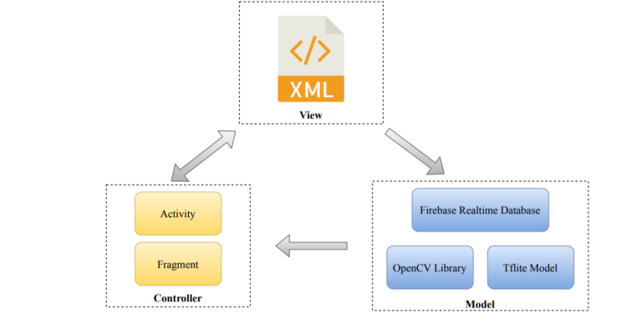

In this project, the application is designed based on Model-View-Controller (MVC) architecture pattern as shown in Figure MVC is a solid, established pattern that aims to isolate and separate the different aspects of an application into presentation and interaction. Each layer is responsible for an aspect of the app. According to MVC architecture pattern, there are 3 logical components that interact with each other which are Model, View and Controller. The Model component is the data layer, responsible for managing the application logic and data as well as handling associated operation on that data. Examples in this project are Firebase real-time database, OpenCV library and Tensorflow Lite model. View is the UI layer which defines and manages how the data from the Model is presented to the user data. Controller is the logic layer, responsible for managing of the user’s behaviour and interaction such as item click event and updating the Model if needed. In this approach, every Activity and Fragment class in the application will act as Controller layer such as click listeners and item click listeners and etc.

In this project, the system requires accurate body skeleton joint positions and body measurements for fitting garment to human body seamlessly to create a realistic image of how garment looks on human body. Hence, the accuracy of human body detection and scanning system should be high to achieve the goal. Besides, model of garment should have correct information including size and style of the actual garment.

This is to avoid misleading users to purchase garment with inadequate size, fit or style. Furthermore, the mobile application should be run with minimal latency to avoid user dissatisfaction. For instance, users will not choose to use the application due to its low speed performance as it does not make any contribution to time advantages for them. Hence, the system should be able to detect human body and apply garment on it within a very short time frame.

* 1. DESIGN DETAILS
     1. SYSTEM ARCHITECTURE

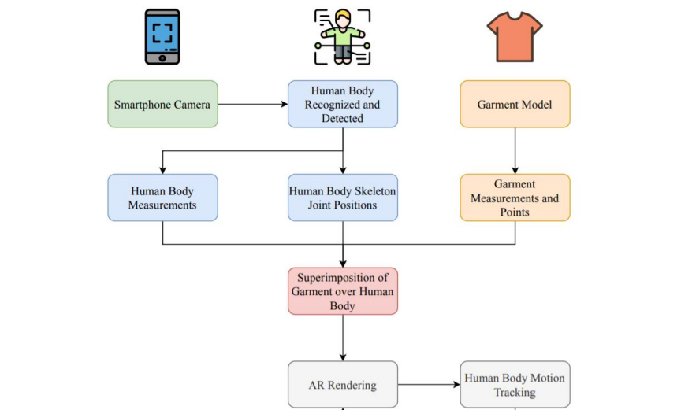

The smartphone camera is used to detect and scan the user’s body in order to obtain body skeleton joint position information and body measurements of the user. Then, the virtual garment is superimposed over the user’s body by computing the data of body measurements, body skeleton joint position and garment measurements. In this way, the virtual garment can be fitted seamlessly to the user’s body for enhanced realism. Through the smartphone camera, the virtual garment follows the tracked user’s body movements with real virtual movements in order to ensure that the virtual garment is fitted to the user’s body. The virtual garment will be kept rendering in the real-world view according to the body movements.

First step of the proposed Online Virtual Trial Room method is the acquisition of the shape of the body, head or neck depending upon the wearable to get reference points. Reference points are then used to determine where to display the particular cloth or ornament. In order to obtain the body shape, we applied several techniques: i) Filtering with thresholding, Canny edge detection, K-means, and ii) Motion detection or skeleton detection wherein multiple frames were analysed for any movement. However, the results were unreliable and not good enough to obtain reference points for displaying the wearable. Therefore, we introduced a new detection methodology based on locating the face of the user, adjusting a reference point at his/her neck and displaying the wearable based on that point. In addition, another point of reference can be obtained by using an Augmented Reality (AR) marker. Though this was enough for small attires like glasses or ornaments but it was not enough to map the clothes onto the user body

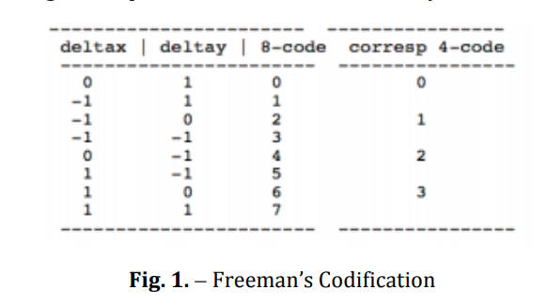

For obtaining the size of the user, we follow a similar automated body feature extraction technique as shown in [7]. The idea is to set up the user in front of the camera and hold him at the beginning at a certain predetermined distance. The algorithm extracts points on the shoulders and the belly. Measuring the distance between these points and knowing the distance from the user to the camera, the size of the user can be obtained. When the image (video frame) is acquired, a canny edge detection filter is applied to obtain only the silhouette of the body. Canny edge detection is really susceptible to noise that is present in unprocessed data; therefore, it uses a filter where the raw image is convolved with a Gaussian filter. After convolution, four filters are applied to detect horizontal, vertical and diagonal edges in the processed image. Morphological functions are also applied to obtain a closed silhouette. Finally, an 8-points Freeman chain code, shown in Figure 1 is applied to assign a direction to each pixel. We can choose to apply 8 or 4 chain code, then the following formula can be used:

z = 4*(deltax+ 2)+(deltay+ 2)

which gives the sequence corresponding to rows 1-8 in the preceding table: z = {11,7,6,5,9,13,14,15}. These values can be used as indices into the table, improving the speed of computing the chain code. Each variation between consecutive numbers represents a variation of 45º so if the difference of direction between consecutive points is measured and if the change is more than two (90º) then a feature point is detected and marked in the image.

ek =| dj + 1 − dj |= 2

This is the same than saying that the absolute difference between two points is bigger than 2 as Eq. (1.2) States. Finally, the distance between them is measured in the image and related to the distance from user to the camera to obtain the size.

**2. Face Detection**

As when the user comes in front of the screen, to detect the user the discrete structure which is to be identified is the face. So, to detect the face, we use Haar feature-based cascade classifiers. In haar classifier instead of using intensity values of the pixel, it uses the change in contrast values between adjacent groups of pixels. Then the variance difference between the pixel groups is used to determine the relative light and dark areas in the image [8]. It is a machine learning approach. So, to work well with the algorithm the cascade function is trained from a lot of negative and positive images. A lot of negative images (images without faces) and positive images (images with faces) are shown to the classifier to train it so it can extract features from it. The purpose of using OpenCV makes it easier as it comes with pre-trained classifiers for face, eyes, smile etc. It comes with a trainer and a detector; we can train it with our own classifier easily for any object detection. If it finds a match it returns Rect (x, y, w, h) implying coordinates for left, top, bottom and right. 3.3. Image Masking In this simply the image masked has some of its pixel intensity values set to zero. In the image wherever the pixel intensity value is zero automatically the pixel intensity of the resulting masked image will be set to the background value which is normally zero. Or To define the mask the ROIs for each slice is used. If required, masking can be controlled on slice by slice basis in ROI toolkit. In ROI toolkit, masking operations does not affect a slice without ROI. 3.4. Edge Detection There are various edge detection techniques. We have used Canny Edge detection technique [9] as discussed before for detection of body. To perform this edge detection technique Gaussian filters are used. These filters cut out the noise in a digital image to prevent any false detection by the processor. This does the work of smoothening and reducing the effect of noise on the image for the proper functioning of the processor. With this the intensity gradients of the image are not found out. The edges in the image can point in various directions like horizontal, vertical and in diagonal edges, so this algorithm uses four filter to detect all kind of edges in blurred image. After this process non-maximum suppression is applied to make the edge thin. This suppression results in quite accurate edge pixels in reference to present real edges. Also, some pixels may be Scaling means resizing of the image according to the circumstances. As when the user moves in front of the screen it should change the sizing of the attire and place it on the body accordingly. When the user moves towards the screen the image size should be increased according to user but the actual measurements of the attire should not increase. Suppose the person is trying out clothes with a measurement size S, as when the person moves in front of the screen the size should not change to a size M or L. Just the overall view of the cloth should be increased or decreased accordingly. This is done by scaling method.caused by the noise, then for such pixels we apply double threshold on them.

* 1. METHDOLOGY/PROCEDURES

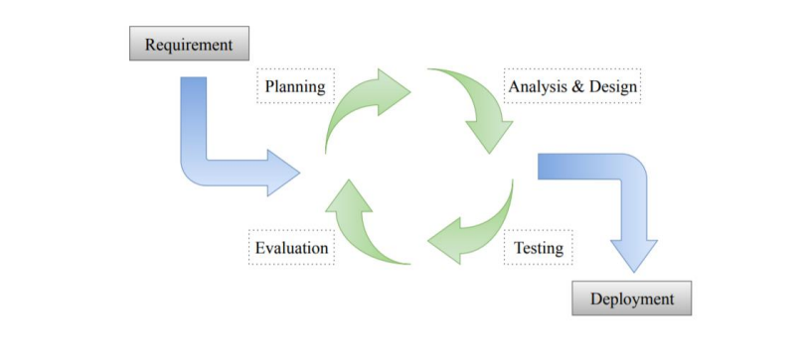

The methodology chosen to be applied in the development of AR virtual fitting room application is iterative model. Iterative model is a particular implementation of a software development life cycle (SDLC) that focuses on an initial, simplified implementation, which then progressively gains more complexity and a broader feature set until the final system is built entirely. It is an approach of breaking down the large software development process into smaller pieces. As shown in Figure 4.1, there are 6 main stages in iterative methodology: Requirement, Planning. Analysis and Design, Evaluation, Testing and Deployment. The reason to choose to apply iterative model in the development is because of its high flexibility compared to other methodologies. With the methodology, a part of the application can be implemented by starting with small sets of requirements in order to adapt the ever-changing scope and requirements with minimal losses in terms of time and cost. For additional requirements, functions are added or changed to meet the requirements in the next iteration in order to create a new version which is an improved version of previous iteration. Moreover, the application is easier to be tested and evaluated during an iteration in order to identify and manage risks. Any potential defects can be recognized quickly and reverted back to previous iteration within a short time frame. Besides, blueprint and prototype of the application can be presented to users to acquire reliable feedback which is important in improving the application. In short, the scope and requirements that were previously set can be enhanced in order to help the developers to build and deliver a quality system quickly and easily with iterative model.

The application is developed with Python Flask Web Application Interface. The user can view clothes and other wearables on the website and choose to buy or try on the attire. If the user wants to try on the wearables online then they must click on the ‘Quick View’ button. This will run the Tryon script. Through OpenCV the video is captured via the device camera and the attire image is super imposed on the user’s body in real time. If the user likes the attire then they can choose to buy it or keep looking at more wearables on the website just like an offline store.

Screenshots of our software

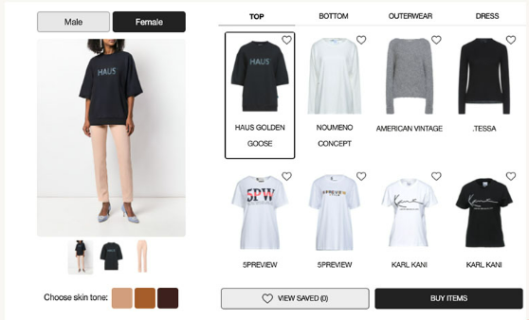

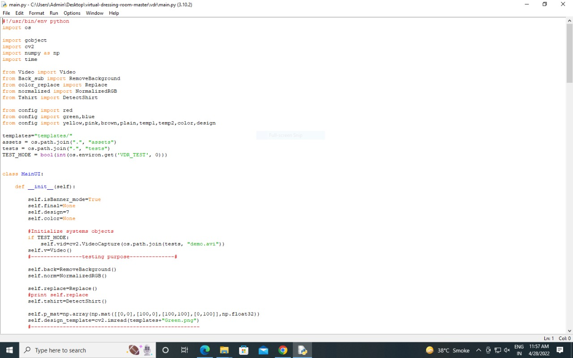

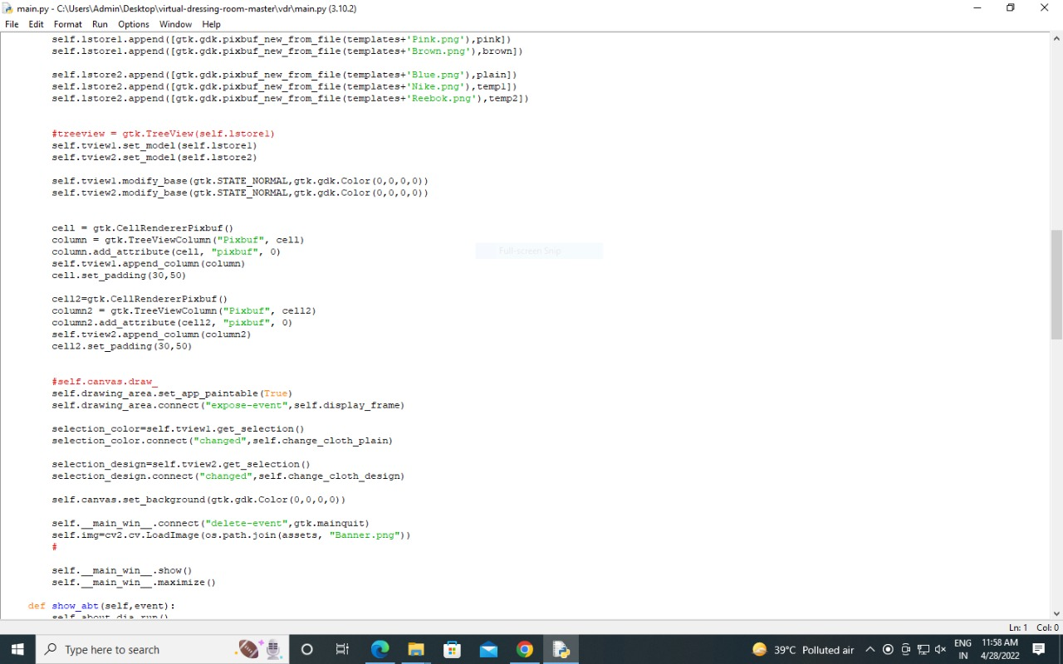

**4. RESULT AND DISCUSSIONS**

* 1. RESULTS, DISCUSSION- COMPARATIVE STUDY/ ANALYSIS

Recent advancements in online shopping has enabled customers to purchase items anywhere and anytime. Although there are several advantages of online shopping, but there is one huge problem that stops most people from shopping online, which is unable to try things on especially for clothing. On the other hand, clothing shopping may be a tedious and troublesome for some in-store customers which does not wish to waste time in the fitting room. In fact, both of the online and in-store customers wish to check whether the clothing fits in size and style in a more time-saving, efficient and convenient way. Hence, this project aims to develop an AR virtual fitting room for customers to perform clothing fitting without physically trying it on body. In this project, the AR virtual fitting room application is designed to be lightweight and efficient that can be run on inexpensive hardware which is Android smartphone. Hence, users are allowed to experience AR and the body detection system by only installing the mobile application instead of whole system. In addition, the Graphical User Interface (GUI) of the application is simple and easy to use to make it applicable to people in all age groups. Users are able to get started with it quickly and easily. Basically, human body is detected, recognized and tracked using smartphone camera in order to interact with the application content in real-time. Pose estimation is implemented to detect human body skeleton joint positions so that body movements can be tracked over the time. The body measurements can be obtained by calculating the distance between each of the skeleton joints detected. Then, the model of garment is fitted to the human body based on the body skeleton joint positions, body measurements as well as the garment measurements. The application is developed with great system performance in terms of accuracy to avoid misleading users to purchase garment with inadequate size, fit or styleneeded for human body detection and fitting the garments onto the human body is short to attain convenient purpose. Besides, the application supports detecting human body in various type of environmental conditions such as low brightness, cluttered scene and etc. so that users are able to try clothing on anywhere and anytime. As a result, the objectives mentioned are achieved

1. **CONCLUSION FUTURE WORK**

In this project, the proposed application has achieved the objective stated and solved the main problem that is currently met by most of the customers who like to shop online. Customers are allowed to check for fit, size or style while shopping online by using the application to try garment on virtually using AR. Although the application is said to have brought a lot of benefits to E-shopping industry, there are some improvements that can still be made to develop a better version of application in terms of convenience, accuracy and interaction. For future plan, recommendation system can be introduced to provide recommendations of clothing according to user’s purchased history or wish list. The garments which users are most likely to purchase should be shown prior to the unlikely ones in order to enhance customer experience. Apart from that, body segmentation technology can be applied to increase more body measurements such as waistband, back length and etc. to improve the accuracy of fitting garment onto the body. In addition, after user selected a garment to virtually try it on his or her body, an information about the sizing of the garment such as overfitting or perfectly fit should be displayed to inform the user. Furthermore, motion capture system can be added into the application in the future. It is to allow users to use hand motions to interact with the application content without having to return to mobile device in order to perform operation in a more convenient way. By using this motion capture system, users are able to browse the various options of the garment by just moving arms above head.

1. **REFERNCES**

Alvarez, E. 2017, Gap envisions a future with augmented-reality 'dressing rooms'. Engadget.com. Available from: [3 August 2019].

Doupnik, E. 2016, Zeekit Releases Next Generation of Virtual Fitting Room, New Visualization Features. WWD. Available from: [4 November 2019].

Kincaid, J. 2009, Zugara's Augmented Reality Dressing Room Is Great If You Don't Care How Your Clothes Fit – TechCrunch. TechCrunch. Available from: [1 August 2019].

Nunan, L. 2017, Gap Tests New Virtual Dressing Room. Gap Inc. Available from: [3 August 2019].

Pachoulakis, I. 2012, Augmented Reality Platforms for Virtual Fitting Rooms. The International journal of Multimedia & Its Applications, 4(4), pp.35-46.

<http://eprints.utar.edu.my/3900/1/16ACB04463_FYP.pdf>

<https://4experience.co/virtual-fitting-rooms-how-can-they-benefit-your-business/>

<https://fashionpoliceng.com/lifestyle/virtual-dressing-fitting-rooms-disadvantage/>

<https://www.linkedin.com/pulse/virtual-dressing-room-market-size-cagr-forecasts-2027covid-ubella/>